**Memo**

To: Professor Pisano

From: Bailey Brake, Ruohui Huang, Emily Lampat, Khang Le, Yuri Zhang

Team: 9

Date: 4/11/2024

Subject: Final Prototype Test Report

# Test Setup

## Bill of Materials:

**Hardware**:

* LED Light: Selected for its efficiency and brightness, which are crucial for our application.
* Arduino Nano Microcontroller: Selected for its compact form factor and streamlined functionality, perfectly suited for our T0 prototype design.
* Adafruit Trinket Microcontroller: Selected for its tiny size and essential features for the T9 model
* Oscilloscope: Essential for accurately measuring the LED's flicker frequency and ensuring our product meets the required specifications.
* Probes/Wires: For connecting and testing the circuit.
* Laptop Computer: Used for programming the Arduino and monitoring the test.
* Phone with USB-C port: Used to power T9 model
* Tactile Push Buttons: For manual control over the LED's ON/OFF Level. (For T0)
* 3D Printed Housings: Custom-made models for the T0 and T9

**Software**:

* Arduino IDE
  + Arduino script to generate 40Hz(±1.3 Hz) light frequency.
  + Take buttons as input to write into LED output, acting as power source

## Setup Procedure:

T0 Model:

Our setup has been carefully designed to replicate a natural application environment. We have a pre-test setup and a setup procedure. In order to ensure our test goes seamlessly, we have uploaded the Arduino code onto our Arduino Nano, and have the Nano along with the circuitry board be integrated onto the back of our LED panel. At the front, we have placed the phone holder where the user places their phone and is able to use it.

As for the setup before our prototype test, we simply connect the Arduino Nano into a wall plug as the power source, place a temporary stand so that our LED panel does not have to put it flat onto the table. All of the setup procedures went according to plan, as outlined in our test plan. Below are pictures of how our prototype test setup turned out to be.

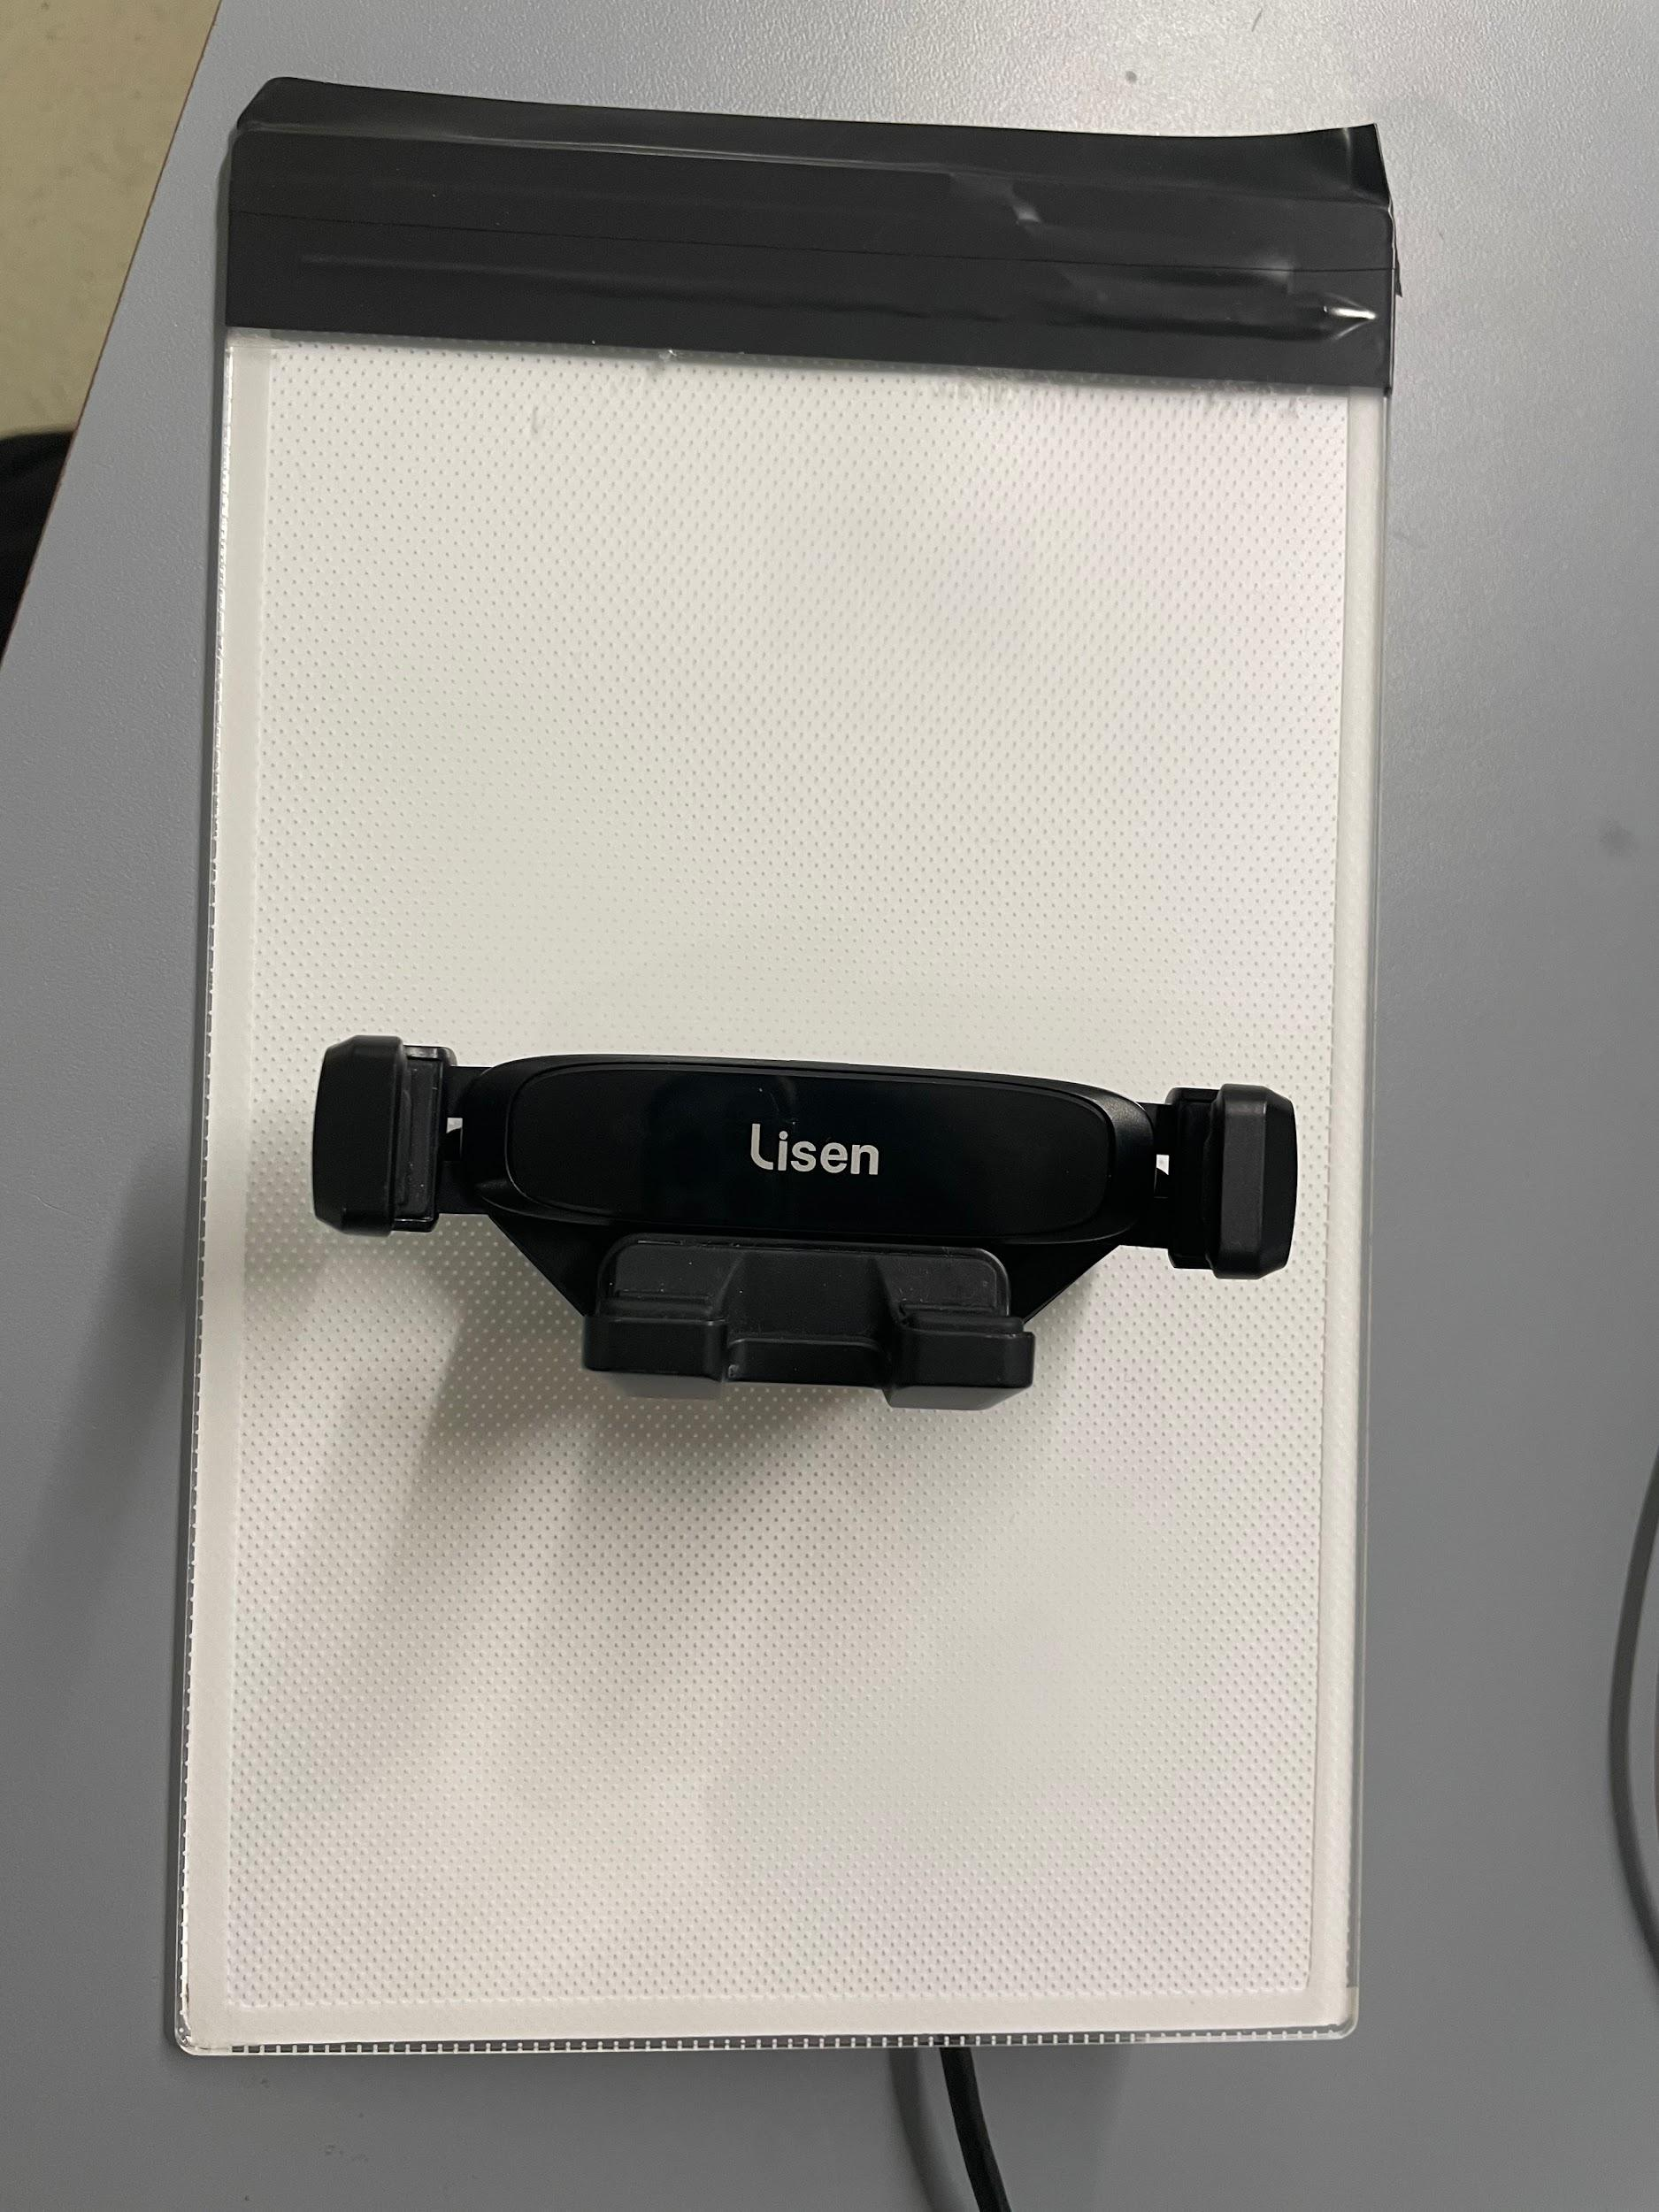

Figure 1.1 Front of LED Panel T0 Model

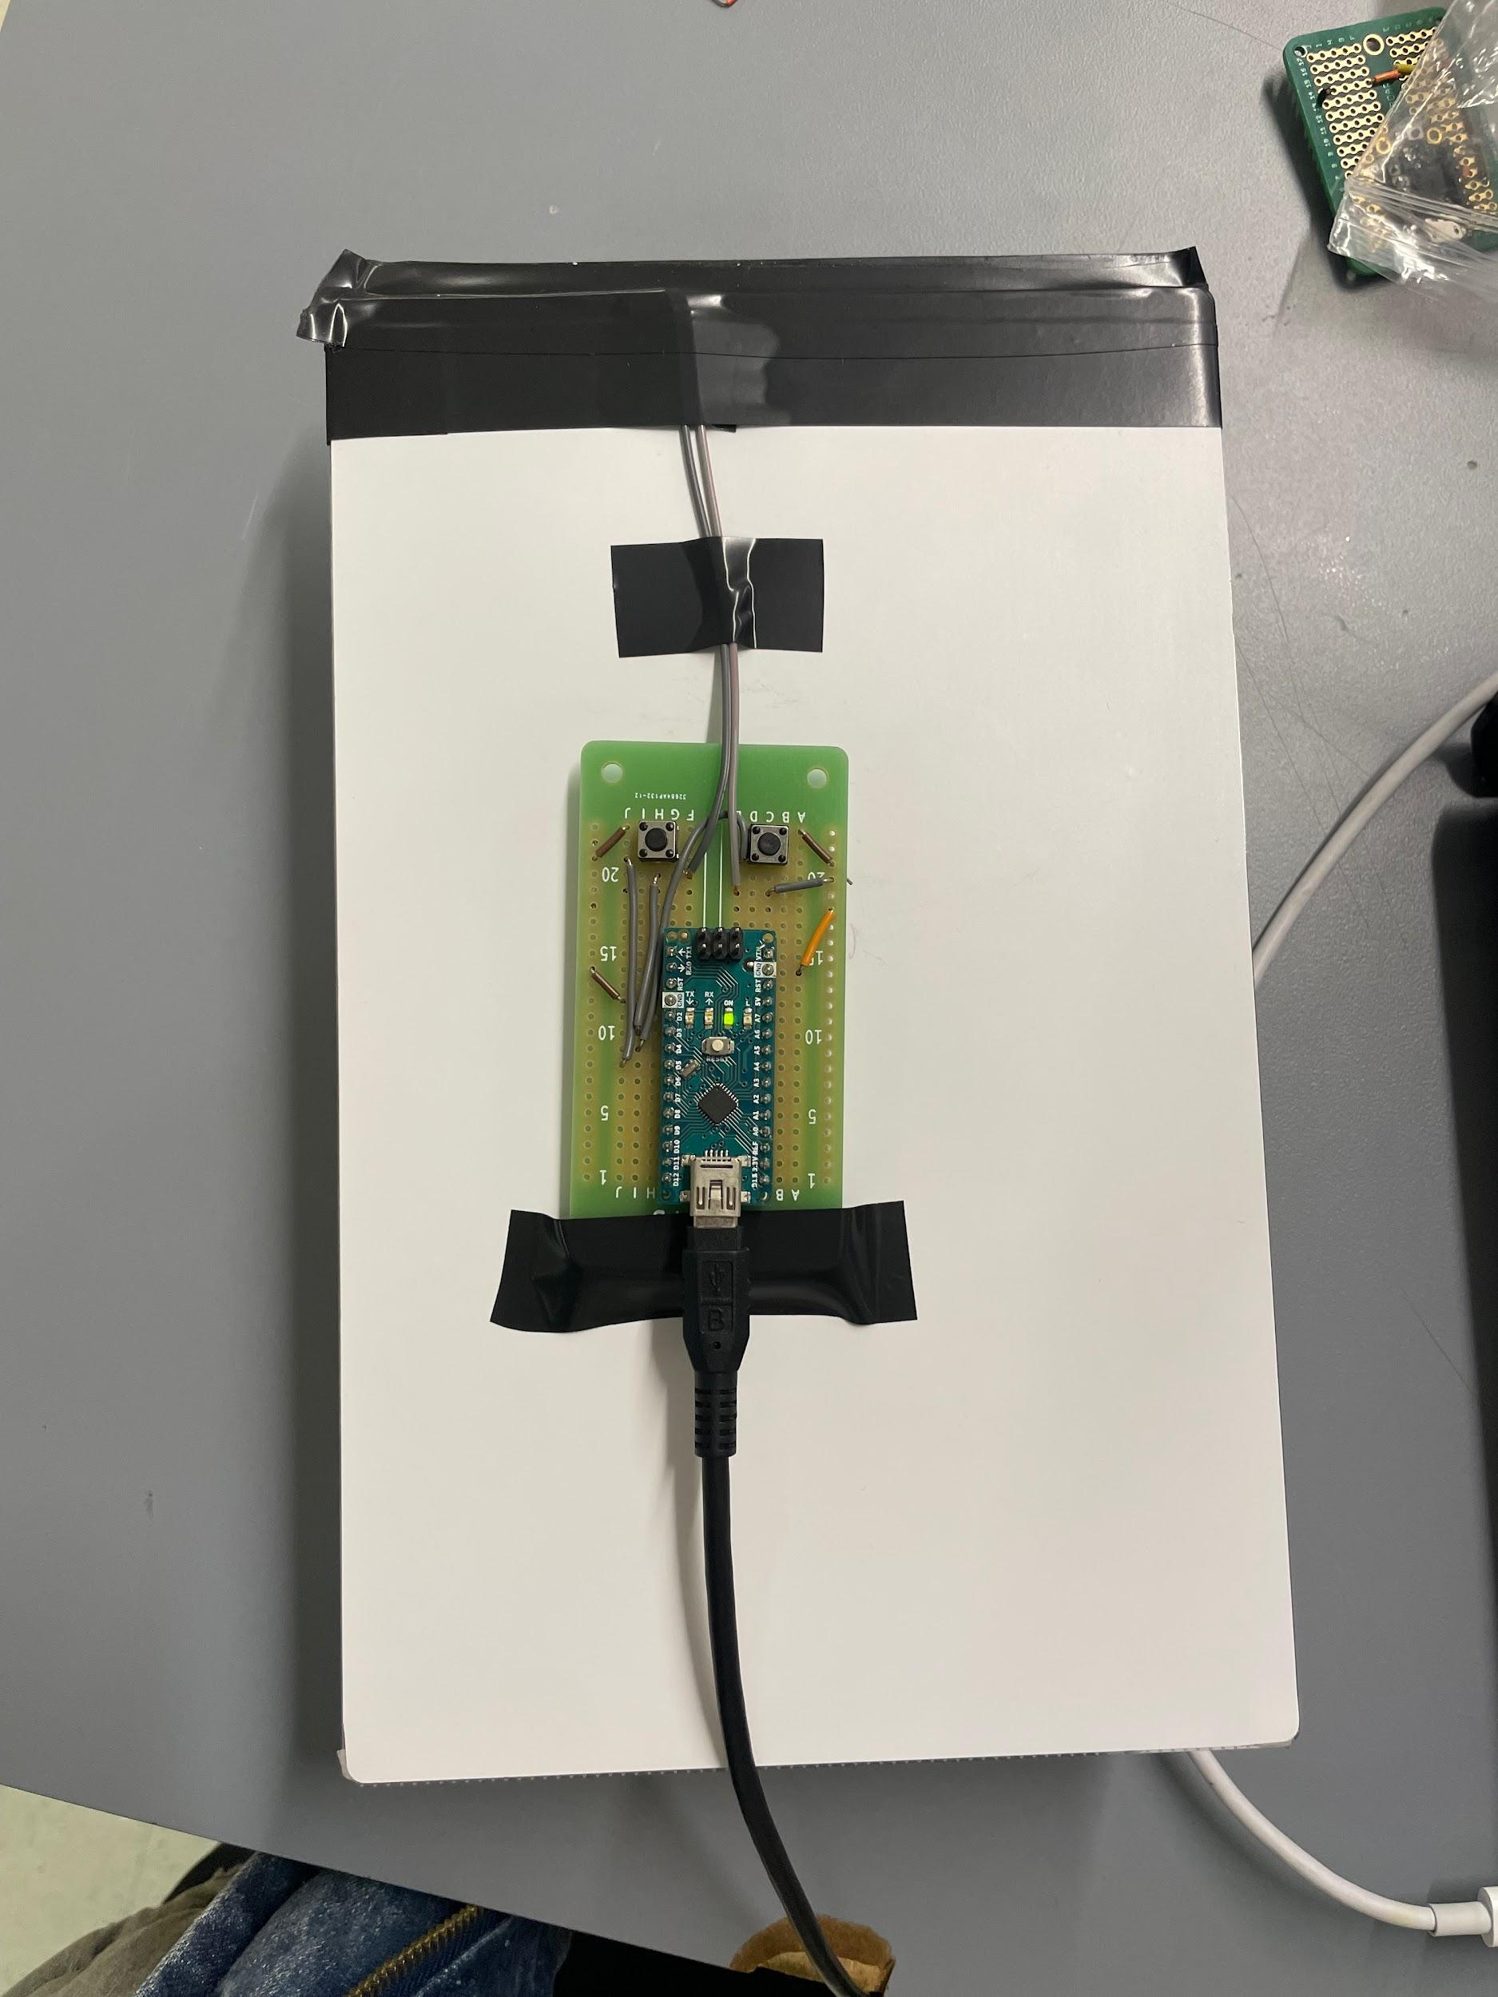

Figure 1.2 Back of LED Panel T0 Model

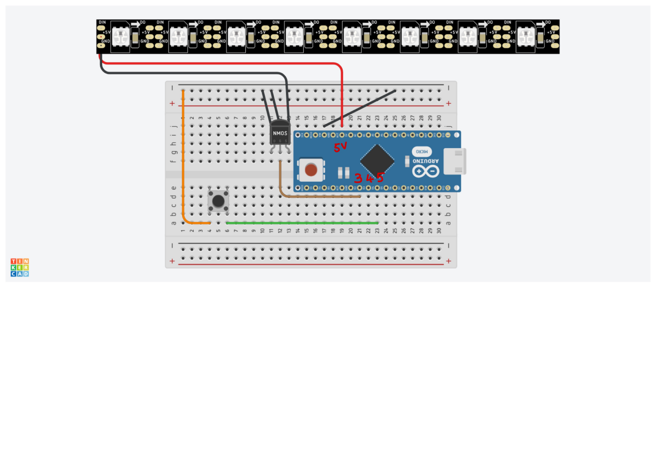

Figure 1.3 Circuit Diagram of the T0 Model

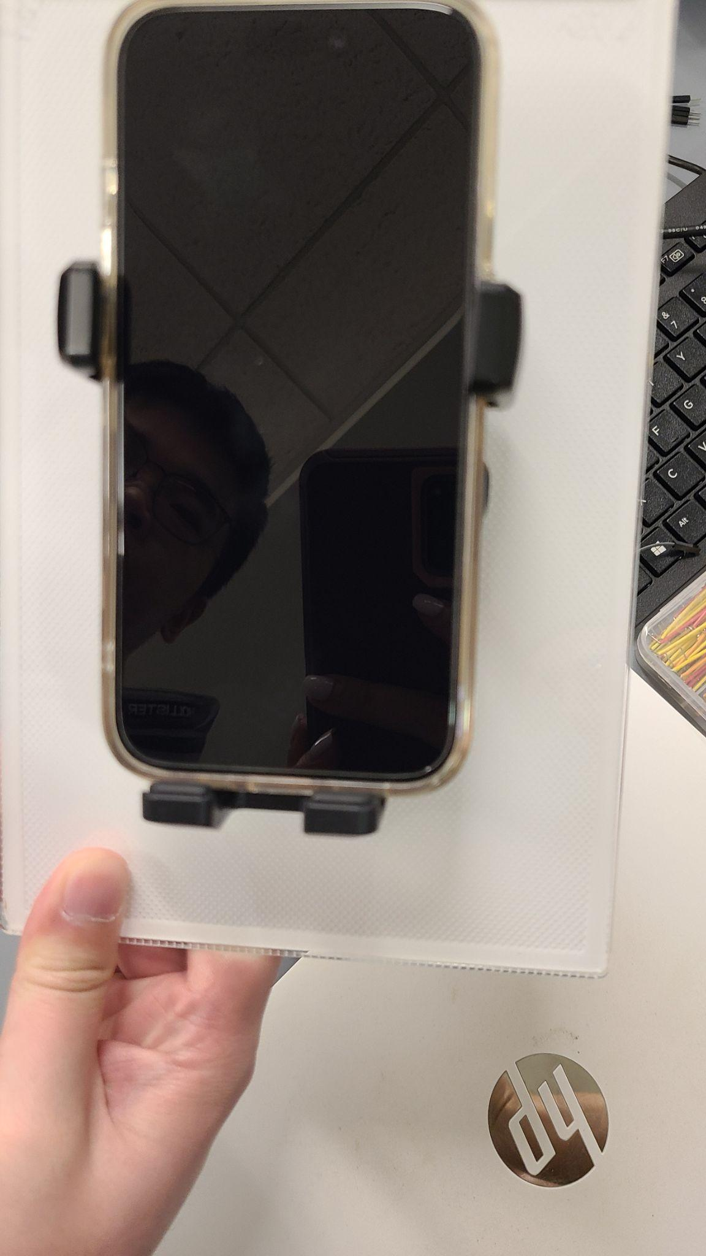

Figure 1.4 Phone placed in holder for T0 model LED Panel

T9 Model:

As for the setup for our T9 model, it consists of an Adafruit Trinket M0 microcontroller that has the Arduino code uploaded and embedded into it. Instead of having the Nano in the circuitry board, we have the Trinket M0 integrated, with an additional button on the circuitry as shown in Figure 1.6 of our circuit diagram. We had the housing implemented around the circuit board, and would apply velcro onto the user’s phone case.

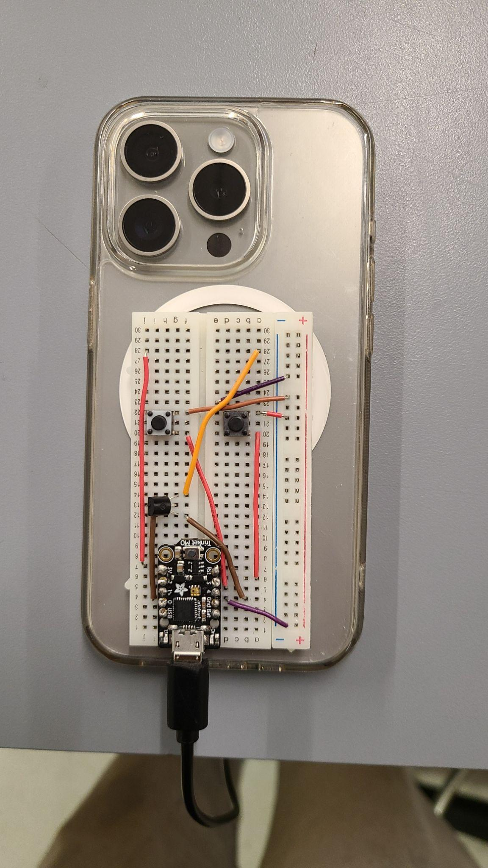

Figure 1.5 T9 model attached to the back of the phone.

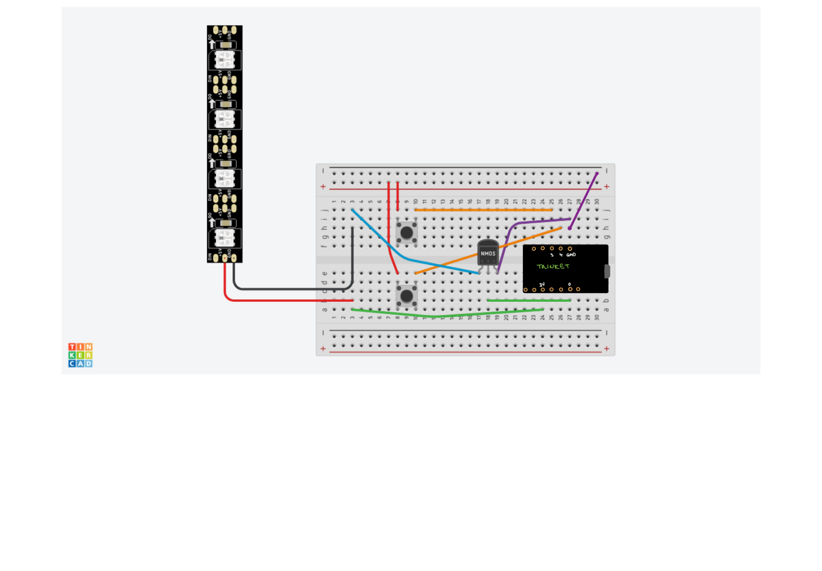

Figure 1.6 Circuit Diagram of the T9 model

# Results and Measurements

## Flicker Frequency Measurement:

In order to measure the flicker frequency, we set a time interval of 25ms on the oscilloscope, which is the desired time period of a flicker, considering we want 40Hz and:

$t = \frac{1}{f} = \frac{1}{40Hz} = 0.025s$

The LED's on-off cycle was observed to be consistent within this timeframe, with a deviation of less than 0.5ms, indicating high precision in frequency control. Below was the result for our flickering rate, where the span that we see at the top was set to be 0.5ms, which encapsulated the cycles of on/off.

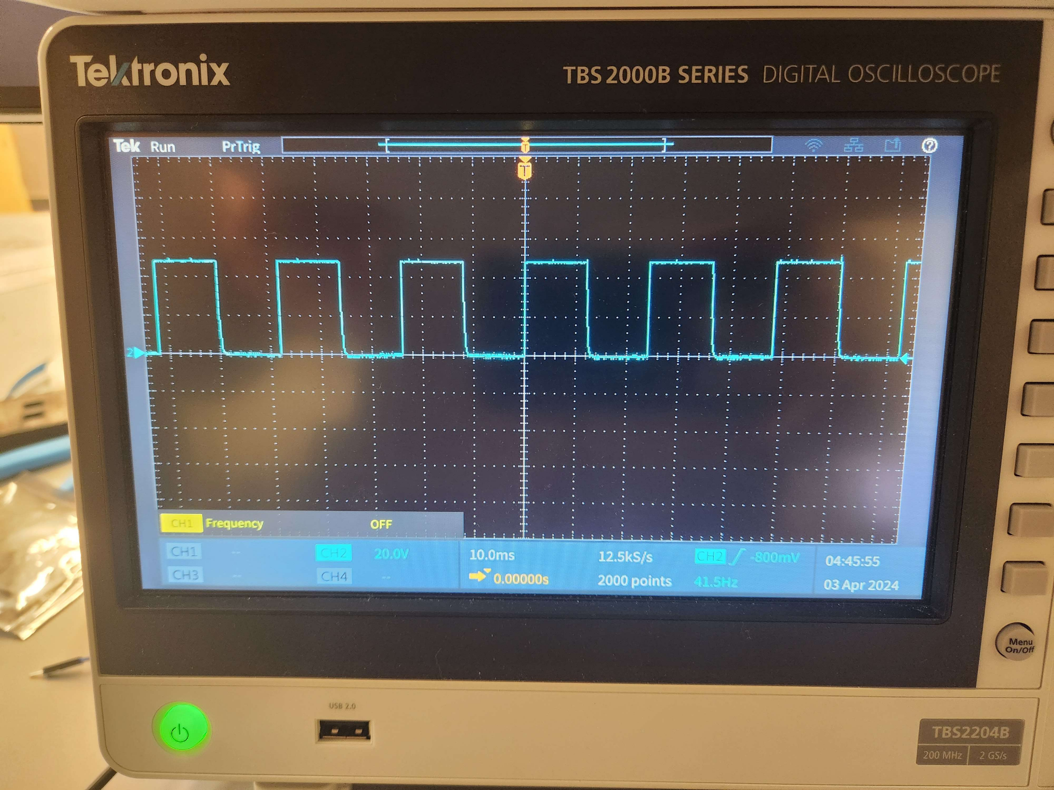

Figure 2.1 Oscilloscope Reading from T0 model

## ON/OFF Toggle Button Measurement:

For our ON/OFF toggle signal button, we measured how long it takes for the LED flickering to turn off upon a click on the button. We made several measurements with different intervals of the button click, to ensure that our debouncer was working properly and that the signal was being transmitted flawlessly with no delay or latency. The intervals between each toggle consisted of: {2 seconds, 1 second and 50 millisecond} apart. The result was that the LED was able to turn on and off according to the button click well within 1 second.

## Brightness Adjustment Buttons Measurement:

We qualitatively measured the brightness upon clicking/holding the buttons. We made sure to do this multiple times, each with different duration of holding the buttons, and also checked corner cases (i.e. the maximum and minimum brightness of the LED). The intervals of holding down each button were: {1 second, 3 seconds, 5 seconds} for both increasing and decreasing brightness. The result was that the LED successfully adjusted its brightness accordingly for all time intervals, as it stayed at its maximum brightness even if we pressed the increased brightness, and turned the LED off even when we held down the decrease brightness button.

# Conclusion and In-Depth Analysis

# 3.1 Conclusion:

The final tests for both the T0 and T9 prototypes were undoubtedly successful. Both models exhibited the necessary requirements and showed great improvement from our last iteration of tests. Notably, this was the first official debut of the T9 and it went smoothly. In addition, we introduced new housings to each model, which greatly improved the form factor of the designs. We now have two prototypes that we are comfortable showing off at ECE day, and still a month left to make improvements.

# 3.2 Future Directions:

This was the final test, but there will always still be improvements to make. The most glaring need is for the circuitry to move from a solderless breadboard to a PCB. During the last several weeks, we had been using a soldered breadboard for both models, but that approach made debugging the circuits incredibly difficult and ended up entirely breaking the T0’s circuit only a few days before testing. As such, both models were implemented using a solderless breadboard, which is more easily manipulated, at the cost of wire stability and increased size. Therefore, producing a more professional and effective PCB would make a massive difference, and would provide a lot more security on ECE day, knowing that our designs won’t break at the most important time.